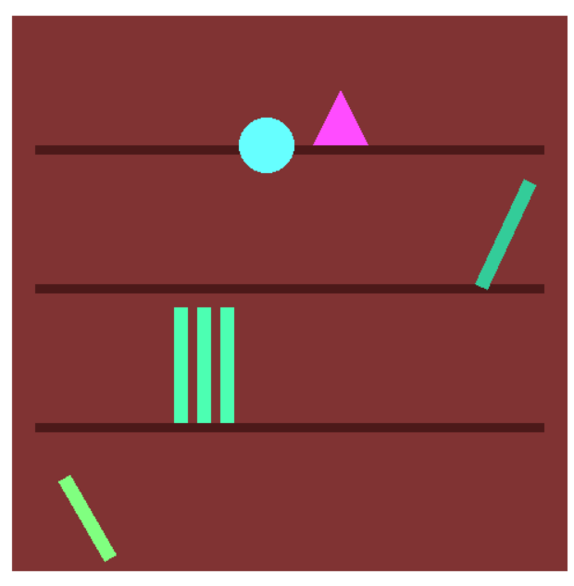
#include "glut.h"
#include <cmath>
using namespace std;

void drawRect(float x, float y, float width, float height, float r, float g, float b) {
glColor3f(r, g, b);
glBegin(GL_QUADS);
glVertex2f(x, y);
glVertex2f(x + width, y);
glVertex2f(x + width, y + height);
glVertex2f(x, y + height);
glEnd();
}

void drawCircle(float cx, float cy, float radius, float r, float g, float b) {
glColor3f(r, g, b);
glBegin(GL_TRIANGLE_FAN);
glVertex2f(cx, cy);
for (int i = 0; i <= 100; i++) {
float angle = 2.0f * 3.14159f * i / 100;
glVertex2f(cx + radius * cos(angle), cy + radius * sin(angle));
}
glEnd();
}

void drawTriangle(float x, float y, float size, float r, float g, float b) {
glColor3f(r, g, b);
glBegin(GL_TRIANGLES);
glVertex2f(x, y);
glVertex2f(x + size, y);
glVertex2f(x + size / 2, y + size);
glEnd();
}

void display() {
glClear(GL_COLOR_BUFFER_BIT);

drawRect(-0.6f, -0.6f, 1.2f, 1.2f, 0.5f, 0.2f, 0.2f); // màu nâu

/
float shelfY[] = { -0.3f, 0.0f, 0.3f };
for (int i = 0; i < 3; i++) {
drawRect(-0.55f, shelfY[i], 1.1f, 0.02f, 0.3f, 0.1f, 0.1f);
}

drawCircle(-0.08f, 0.36f, 0.06f, 0.4f, 1.0f, 1.0f);
drawTriangle(0.0f, 0.3f, 0.06f, 0.4f, 1.0f, 1.0f);

glPushMatrix();
glTranslatef(0.4f, 0.02f, 0.0f);
glRotatef(-25, 0.0f, 0.0f, 1.0f);
drawRect(0.0f, 0.0f, 0.03f, 0.25f, 0.2f, 0.8f, 0.6f);
glPopMatrix();

drawRect(-0.25f, -0.28f, 0.03f, 0.25f, 0.3f, 1.0f, 0.7f);
drawRect(-0.20f, -0.28f, 0.03f, 0.25f, 0.3f, 1.0f, 0.7f);
drawRect(-0.15f, -0.28f, 0.03f, 0.25f, 0.3f, 1.0f, 0.7f);

glPushMatrix();
glTranslatef(-0.4f, -0.58f, 0.0f);
glRotatef(30, 0.0f, 0.0f, 1.0f);
drawRect(0.0f, 0.0f, 0.03f, 0.2f, 0.5f, 1.0f, 0.5f);
glPopMatrix();

glFlush();
}

void init() {
glClearColor(1.0, 1.0, 1.0, 1.0);
glMatrixMode(GL_PROJECTION);
gluOrtho2D(-1.0, 1.0, -1.0, 1.0);
}

int main(int argc, char** argv) {
glutInit(&argc, argv);
glutInitWindowSize(800, 800);
glutCreateWindow("Gia Sach - OpenGL");
init();
glutDisplayFunc(display);
glutMainLoop();
return 0;
}

